# GitHub Basics

##### Beginner level

1. What is GitHub?

Github is a cloud platform that provide services for various development tasks where,

we can share,build and easily bring out the changes that done by other team members.

It also helps to improve the way the team works together, and get access to more features.

2. What are the advantages of GitHub?

Github is a cloud repository all the software process is easily available.

Helps to maintain same phase in the team

Easy availability of tasks being done in various form like documents,source code etc

Easily know the changes required ,and changes done

3. What is commit, push, pull?

.Commit :Any changes done is implemented and newly created

Push :Changes done is stored in the cloud

Pull :Changes done by other member is fetched by others to view

4. What is pull request?

Pull requests informs about changes pushed to the Github.

By pull request we can view about the changes and modifications.

5. How to create repository?

File>>New Repository>>Name ,Description>>Create Repository

6. How to add collaborators?

7. How to merge master to your branch? (Attach screenshots).

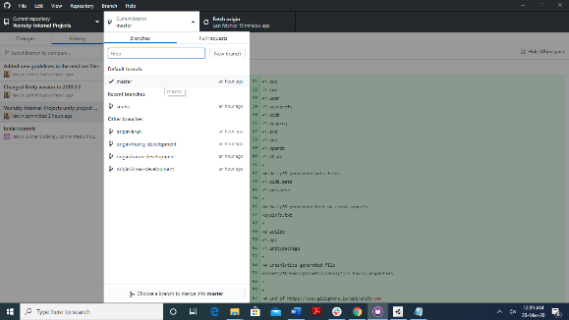 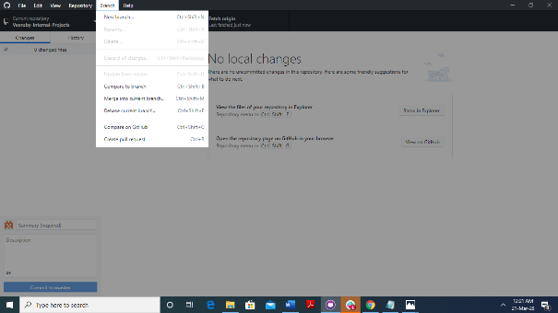

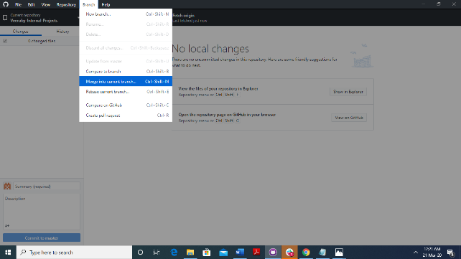 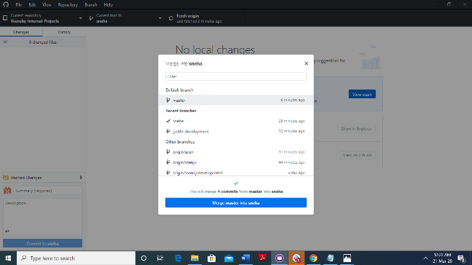

8. How to merge your branch into master? (Attach screenshots).

9. How to create pull request? (Attach screenshots).

10. How to create branch? (Attach screenshots).

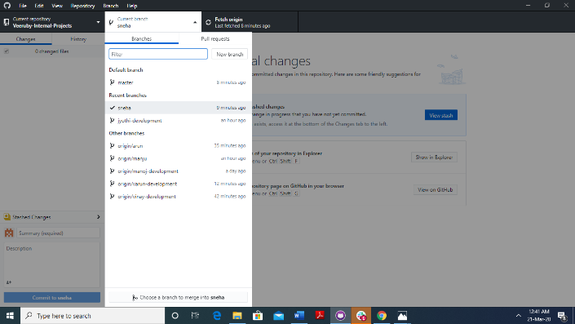

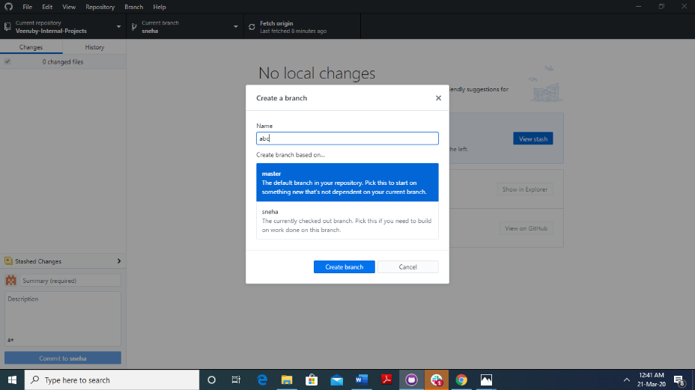

11. How to delete branch? (Attach screenshots).

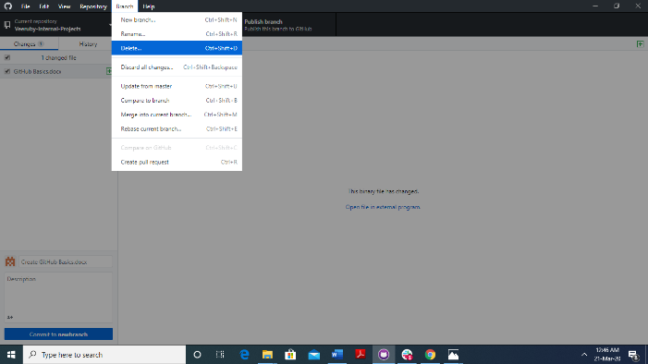

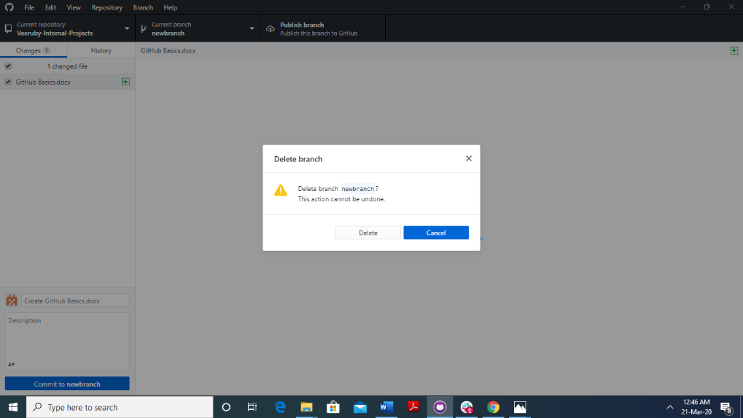

12. How to delete repository? (Attach screenshots).

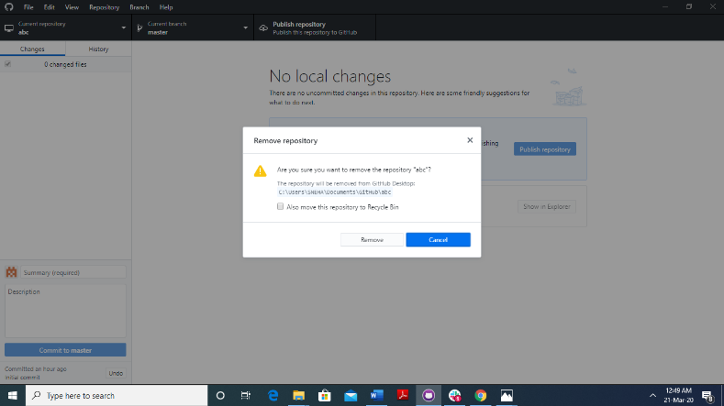

##### Intermediate level

12. What is fork?

13. How to create fork? (Attach screenshots).

14. How to merge changes from fork to master project? (Attach screenshots).

15. How to Undo commit changes? (Attach screenshots).

16. What is revert?

17. How to revert changes? (Attach screenshots).

##### Advanced level

18. What is LFS?

19. How to install LFS and add LFS file into it? (Attach screenshots).

20. How to push LFS commits? (Attach screenshots).